
NOTICE
TO: All Captive Managers
FROM: Captive Insurance, Office of the Commissioner of Securities & Insurance (CSI); 406-444-3513; csi.captives@mt.gov
SUBJECT: Annual Reporting Instructions Montana-domiciled Captives

Unaudited Financial Statements (Annual Statement or Annual Report)
Pursuant to Mont. Code Ann. § 33-28-107, on or before April 1 of each year, the captive insurer shall submit to the Commissioner, on a form prescribed by the Commissioner, a report of its financial condition. Each captive insurer shall report using generally accepted accounting principles (GAAP). Modifications or adaptations to standard GAAP accounting may be used only with the prior written approval of the Commissioner.

Non-risk retention groups (“non-RRGs”) may use the “MT Short Form” for the annual filing:
https://csimt.gov/wp-content/uploads/2026/01/UPDATED-CAPTIVE-MT-SHORT-FORM-ENDING-2025-2.xlsx

Fiscal Filers may use the “MT Fiscal File Form:”
https://csimt.gov/wp-content/uploads/2026/01/CAPTIVE-MT-FISCAL-FILING-FORM.xlsx

The Commissioner may impose a fine for the late filing of an annual report. The fine may not exceed $100 per day, and the maximum fine is $1,000.

Audited Financial Statements
Pursuant to Administrative Rules of Montana (Mont. Admin. R.) 6.6.6811, all nonRRG captive insurers shall have an annual audit by an independent certified public accountant authorized by the Commissioner and shall file such audited financial report with the Commissioner on or before June 30 for the year ending December 31 immediately preceding.
The annual CPA audit report shall be considered part of the captive insurer’s annual report of financial condition except with respect to the date by which it must be filed.

The annual CPA audit shall consist of the following:
- Financial statements furnished pursuant to this section shall be examined by an independent certified public accountant in accordance with generally accepted auditing standards as determined by the American Institute of Certified Public Accountants.
- The opinion of the independent certified public accountant shall cover all the years presented and shall be dated and addressed to the captive insurance company on the accountant’s stationery with accountant’s address and shall bear original manual signature.
The annual CPA audit report shall include an evaluation of the internal controls of the captive insurer relating to the methods and procedures used in the securing of assets and the reliability of the financial records, including but not limited to such controls as the system of authorization and approval and the separation of duties.
The accountant shall furnish the company, for inclusion in the filing of the audited financial report, a letter stating:
- That it is independent with respect to the captive insurance company and conforms to the standards of the profession, as contained in the Code of
Professional Ethics and pronouncements of the American Institute of Certified Public Accountants and pronouncements of the Financial Accounting Standards Board.
- The general background and experience of the staff engaged in the audit including the experience in auditing captives or other insurance companies.
- That the accountant understands that the audited annual report and the accountant’s opinion thereon will be filed with the CSI.
- That the accountant consents to the requirements of Mont. Admin. R.
6.6.6819.
- That the accountant is properly licensed by the appropriate state licensing authority and is a member in good standing with the American Institute of Certified Public Accountants.
The annual CPA audit shall include the following financial statements:
- Balance sheet;
- Statement of operations;
- Statement of changes in financial position;
- Statement of changes in paid up, gross paid in and contributed surplus and unassigned funds (surplus); and notes to financial statements, which shall include those that are required by GAAP, including: (1) A reconciliation of differences, if any, between the audited financial report and the statement or form filed with the Commissioner (i.e., unaudited statement). (2) A summary of ownership and relationship of the company and all affiliated corporations or companies insured by the captive.

Actuarial Opinion
Pursuant to Mont. Admin. R. 6.6.6816, the annual CPA audit shall include an opinion as to the adequacy of the captive insurer’s loss reserves and loss expense reserves. The individual who certifies as to the adequacy of the reserves shall be approved by the Commissioner and shall be a member of the Casualty Actuarial Society, a member in good standing of the Academy of Actuaries, or an individual who has demonstrated competence in loss reserve evaluation to the Commissioner.
The required opinion may follow the NAIC Annual Statement Instructions but is not required to do so. For non-RRG opinions that do not follow the NAIC Annual Statement Instructions, the actuary must still state his or her “opinion” regarding the sufficiency of the company’s loss reserves and loss expense reserves, and the actuary must sign such opinion.

Special Instructions for Cell Reporting
Each Protected Cell Captive Insurance Company (PCC core) and each protected cell (cell) affiliated with the PCC core shall file separate unaudited financial statements on the Montana Short Form on or before April 1st of each year. For example, if there is a PCC core and two cells, then the PCC core files an unaudited financial statement to report on its own business, and each cell files an unaudited financial statement to report the cell’s business.
Each PCC core shall file “combined” audited financial statements with the CSI on or before June 30 of each year. The auditor shall express an opinion on the combined assets, liabilities, capital and surplus of the PCC core and each cell. The detailed assets, liabilities, and capital and surplus balances of the PCC core and each cell shall be disclosed in a supplemental schedule to the financial statements.
Each individual cell shall file an actuarial opinion, certifying the adequacy of the loss reserves and LAE reserves on or before June 30 of each year. An actuarial opinion would also be required for the PCC core, if the PCC core is at risk, i.e., has loss reserves.

Special Instructions for Series LLC Reporting
A Series LLC (Series core) and its series business unit(s) (SBU) may file “combined” unaudited financial statements on the Montana Short Form on or before April 1st of each year.
Each Series core shall file “combined” audited financial statements with the CSI on or before June 30 of each year. The auditor shall express an opinion on the combined assets, liabilities, capital and surplus of the Series core and each SBU. The detailed assets, liabilities, and capital and surplus balances of the Series core and each SBU shall be disclosed in a supplemental schedule to the financial statements.
Each individual SBU shall file an actuarial opinion certifying the adequacy of the loss reserves and LAE reserves on or before June 30 of each year. An actuarial opinion would also be required for the Series core, if the Series core is at risk, i.e., has loss reserves.

Filing Instructions
An electronic copy of the annual statement should be filed with the Montana Department of Insurance and in addition, financial filings are required. See the “Montana Filing Checklist for Captive Insurers” filing requirements and instructions (last page).
It is suggested that electronic filings be made through the Montana File Transfer Service (MFTS). An account can be established at:

https://transfer.mt.gov/Home/Login?EPassError=Unauthorized&ErrorCode=Unauthorized&ErrorMessage=You%20do%20not%20have%20access%20to%20the%20requested%20resource.&ReturnUrl=https%3a%2f%2ftransfer.mt.gov%2f

When using MFTS, you will be asked to enter a receiving email address. Please use the following recipients: rbidon@mt.gov; Dakota.terry@mt.gov

Fiscal Year Filers
Fiscal Filers will use the excel form named the same (link on page 1).
Non-RRGs with a fiscal year-end other than December 31 must request and receive permission from the CSI to file on a basis other than December 31. This request need only be made one time (companies generally request this, and are approved, at time of licensure), but any subsequent changes must also be approved by the CSI. Filing deadlines for fiscal year filers are as follows: unaudited statements are due 90 days after fiscal year-end; audited statements and actuarial opinions are due 180 days after fiscal year-end. Premium tax returns for fiscal year filers are due March 1 as is the case for all captive insurers.

Premium Tax Returns
All Montana-domiciled captive insurers are required to file a Montana Premium Tax Return in OPTins no later than March 1 of each year. Mont. Code Ann. § 33-28-201 allows a quarterly proration of the minimum premium tax for those captive insurers who were newly licensed during the tax year being filed.
The Website instructions regarding OPTins discusses the filing of the Montana Premium Tax Return by the March 1st, due date. Please read it carefully.
Fiscal year filers shall file a Montana Premium Tax Return no later than March 1 of each year for the most recently completed calendar year. This means that for premium tax purposes, fiscal year filers shall convert fiscal year premium data to calendar year data. To support the premium tax return, a fiscal year filer shall attach to the premium tax return a report of monthly written premium and/or reinsurance assumed for the prior calendar year.
PCC core companies shall submit a single premium tax return that combines premium/assumed reinsurance numbers for the PCC core and each cell.
Series core companies shall submit a single premium tax return that combines premium/assumed reinsurance numbers for the Series core and each SBU. The maximum premium tax of $100,000 shall be applied to each SBU of a Series LLC captive, rather than application of the maximum to the captive in aggregate.

Certificate of Authority Renewal
Pursuant to Mont. Code Ann. § 33-28-102(4)(b), all licensed captive insurers
(including each protected cell and each SBU) shall pay a Certificate of Authority
(license) renewal fee of $300. The renewal fee is incorporated into the Montana Premium Tax Return and payment should be remitted therewith. The Commissioner may suspend or revoke a captive’s Certificate of Authority if the renewal fee is not paid by March 1.

Dormant Captives
Pursuant to Mont. Code Ann. § 33-28-401 a dormant captive insurer shall:
- On or before March 1, pay a $1,000 annual dormancy tax. Please use the Dormancy Tax Return in OPTins to report and remit the dormancy tax.
- No later than April 1, submit to the Commissioner a report of the dormant captive’s financial condition as of the preceding year end, verified by oath of two of its executive officers, in a form as may be prescribed by the Commissioner. Please use the Montana Short Form in #1 above.

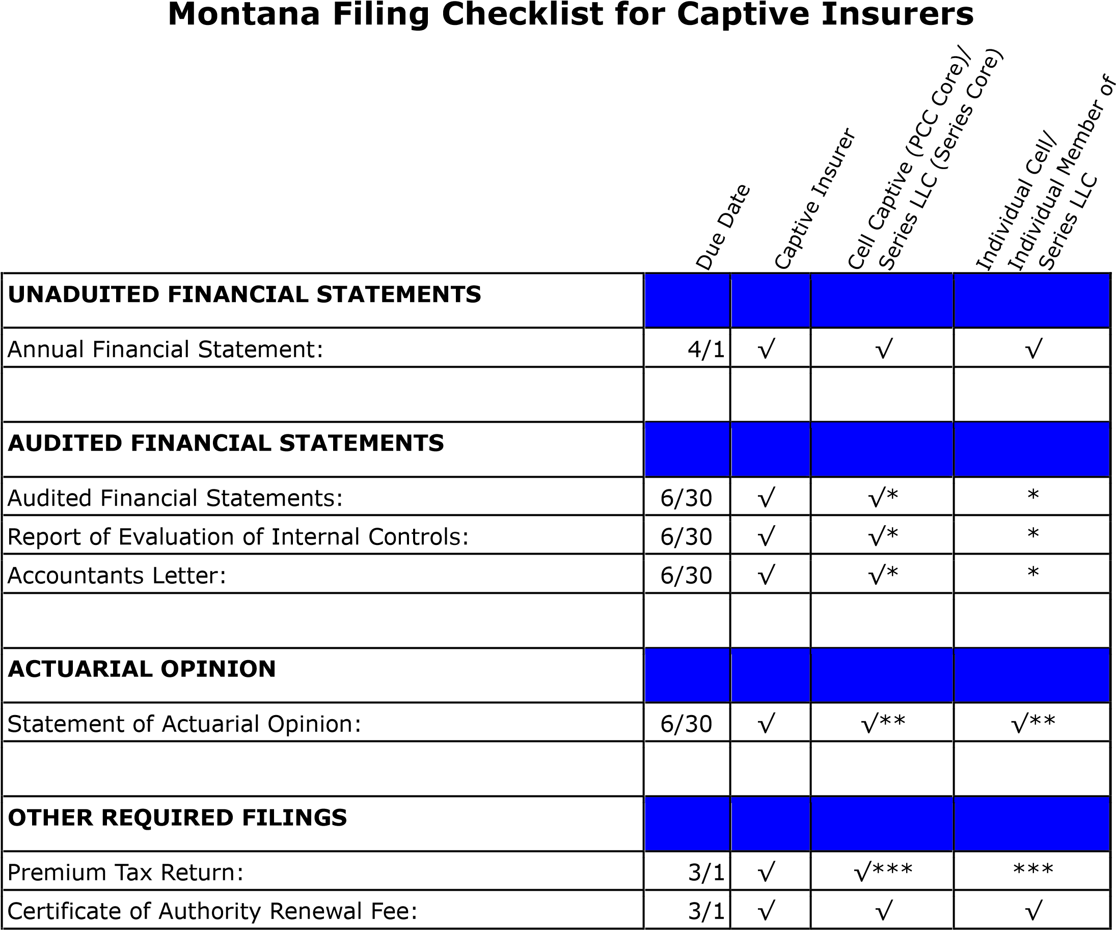
√ Denotes required filing.
* Each Protected Cell Captive (PCC core) and Series LLC (Series core) must file a
"combined" audited financial statement. Refer to "Reporting Instructions" memo.
** Each PCC core must file individual actuarial opinions for each cell and the PCC core (if applicable). Refer to "Reporting Instructions" memo.
** Each Series core must file individual actuarial opinions for each SBU and the Series core (if applicable). Refer to "Reporting Instructions" memo.
*** Each PCC core and Series core must file a combined Premium Tax Return. Refer to "Reporting Instructions" memo.
Note: For captives using a non-calendar year (fiscal year), the due dates in the above checklist do not apply, except for the premium tax return and Certificate of Authority Renewal fee. Refer to "Reporting Instructions" memo.

